**AWS Security - Secrets Manager and Parameter Store**

1. Create a secret in AWS Secrets Manager and use it in an application by referencing its ARN.  
   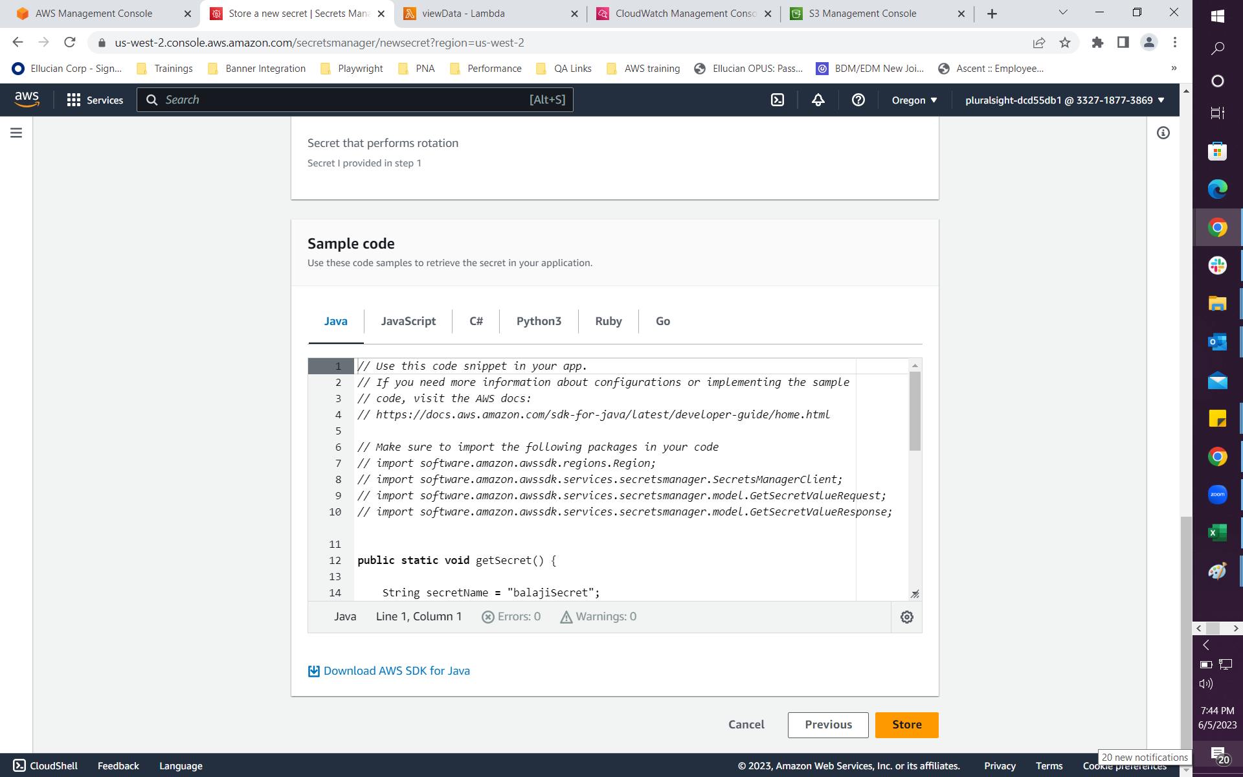  
     
   A screenshot of a computer

   Description automatically generated
2. Rotate a secret in AWS Secrets Manager and update the application to use the new version of the secret.
3. Use AWS CLI to retrieve a parameter from the Parameter Store and display its value.  
   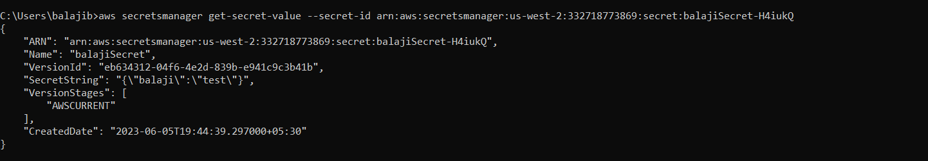
4. Use AWS CLI to create a secret in AWS Secrets Manager and update its value.  
   A picture containing text, screenshot, font

   Description automatically generated  
   A screenshot of a computer

   Description automatically generated with medium confidence
5. Use AWS SDK to retrieve a parameter from the Parameter Store and display its value in a Javascript application.  
   A picture containing text, screenshot, font

   Description automatically generated